***IT TAKES GUTS***

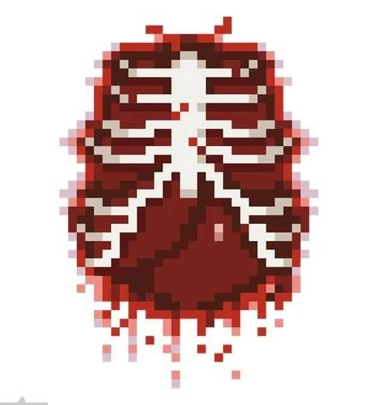

Anthony Norderhaug

Department of Computer Science, San Diego State University

CS 583: 3D Game Programming

Prof. Stephen Price

April 30, 2022

This page: Table of Contents and Team Member Listing

| Table of Contents  [1 Game Overview](https://n-xovwktmtjsnaxyc2mwes2xu7pohqedmdm6zjw5q-2lu-script.googleusercontent.com/userCodeAppPanel)  [2 High Concept](https://n-xovwktmtjsnaxyc2mwes2xu7pohqedmdm6zjw5q-2lu-script.googleusercontent.com/userCodeAppPanel) / Genre  [3 Unique Selling Points](https://n-xovwktmtjsnaxyc2mwes2xu7pohqedmdm6zjw5q-2lu-script.googleusercontent.com/userCodeAppPanel)  [4 Platform Minimum Requirements](https://n-xovwktmtjsnaxyc2mwes2xu7pohqedmdm6zjw5q-2lu-script.googleusercontent.com/userCodeAppPanel)  [5 Competitors / Similar Titles](https://n-xovwktmtjsnaxyc2mwes2xu7pohqedmdm6zjw5q-2lu-script.googleusercontent.com/userCodeAppPanel)  [6 Synopsis](https://n-xovwktmtjsnaxyc2mwes2xu7pohqedmdm6zjw5q-2lu-script.googleusercontent.com/userCodeAppPanel)  [7 Game Objectives](https://n-xovwktmtjsnaxyc2mwes2xu7pohqedmdm6zjw5q-2lu-script.googleusercontent.com/userCodeAppPanel)  [8 Game Rules](https://n-xovwktmtjsnaxyc2mwes2xu7pohqedmdm6zjw5q-2lu-script.googleusercontent.com/userCodeAppPanel)  [9 Game Structure](https://n-xovwktmtjsnaxyc2mwes2xu7pohqedmdm6zjw5q-2lu-script.googleusercontent.com/userCodeAppPanel)  [10 Game Play](https://n-xovwktmtjsnaxyc2mwes2xu7pohqedmdm6zjw5q-2lu-script.googleusercontent.com/userCodeAppPanel)  [10.1 Game Controls](https://n-xovwktmtjsnaxyc2mwes2xu7pohqedmdm6zjw5q-2lu-script.googleusercontent.com/userCodeAppPanel)  [10.2 Game Camera](https://n-xovwktmtjsnaxyc2mwes2xu7pohqedmdm6zjw5q-2lu-script.googleusercontent.com/userCodeAppPanel)  [10.2.1 HUD](https://n-xovwktmtjsnaxyc2mwes2xu7pohqedmdm6zjw5q-2lu-script.googleusercontent.com/userCodeAppPanel)  [10.2.2 Maps](https://n-xovwktmtjsnaxyc2mwes2xu7pohqedmdm6zjw5q-2lu-script.googleusercontent.com/userCodeAppPanel)  [11 Players](https://n-xovwktmtjsnaxyc2mwes2xu7pohqedmdm6zjw5q-2lu-script.googleusercontent.com/userCodeAppPanel)  [11.1 Characters](https://n-xovwktmtjsnaxyc2mwes2xu7pohqedmdm6zjw5q-2lu-script.googleusercontent.com/userCodeAppPanel)  [11.2 Metrics](https://n-xovwktmtjsnaxyc2mwes2xu7pohqedmdm6zjw5q-2lu-script.googleusercontent.com/userCodeAppPanel)  [11.3 States](https://n-xovwktmtjsnaxyc2mwes2xu7pohqedmdm6zjw5q-2lu-script.googleusercontent.com/userCodeAppPanel)  [11.4 Weapons](https://n-xovwktmtjsnaxyc2mwes2xu7pohqedmdm6zjw5q-2lu-script.googleusercontent.com/userCodeAppPanel)  [12 Player Line-up](https://n-xovwktmtjsnaxyc2mwes2xu7pohqedmdm6zjw5q-2lu-script.googleusercontent.com/userCodeAppPanel)  [13 NPC](https://n-xovwktmtjsnaxyc2mwes2xu7pohqedmdm6zjw5q-2lu-script.googleusercontent.com/userCodeAppPanel)  [13.1 Enemies](https://n-xovwktmtjsnaxyc2mwes2xu7pohqedmdm6zjw5q-2lu-script.googleusercontent.com/userCodeAppPanel)  [13.1.1 Enemy States](https://n-xovwktmtjsnaxyc2mwes2xu7pohqedmdm6zjw5q-2lu-script.googleusercontent.com/userCodeAppPanel)  [13.1.2 Enemy Spawn Points](https://n-xovwktmtjsnaxyc2mwes2xu7pohqedmdm6zjw5q-2lu-script.googleusercontent.com/userCodeAppPanel)  [13.2 Allies / Companions](https://n-xovwktmtjsnaxyc2mwes2xu7pohqedmdm6zjw5q-2lu-script.googleusercontent.com/userCodeAppPanel)  [13.2.1 Ally States](https://n-xovwktmtjsnaxyc2mwes2xu7pohqedmdm6zjw5q-2lu-script.googleusercontent.com/userCodeAppPanel)  [13.2.2 Ally Spawn Points](https://n-xovwktmtjsnaxyc2mwes2xu7pohqedmdm6zjw5q-2lu-script.googleusercontent.com/userCodeAppPanel)  [14 Art](https://n-xovwktmtjsnaxyc2mwes2xu7pohqedmdm6zjw5q-2lu-script.googleusercontent.com/userCodeAppPanel)  [14.1 Setting](https://n-xovwktmtjsnaxyc2mwes2xu7pohqedmdm6zjw5q-2lu-script.googleusercontent.com/userCodeAppPanel)  [14.2 Level Design](https://n-xovwktmtjsnaxyc2mwes2xu7pohqedmdm6zjw5q-2lu-script.googleusercontent.com/userCodeAppPanel)  [14.3 Audio](https://n-xovwktmtjsnaxyc2mwes2xu7pohqedmdm6zjw5q-2lu-script.googleusercontent.com/userCodeAppPanel)  [15 Procedurally Generated Content](https://n-xovwktmtjsnaxyc2mwes2xu7pohqedmdm6zjw5q-2lu-script.googleusercontent.com/userCodeAppPanel)  [15.1 Environment](https://n-xovwktmtjsnaxyc2mwes2xu7pohqedmdm6zjw5q-2lu-script.googleusercontent.com/userCodeAppPanel)  [15.2 Levels](https://n-xovwktmtjsnaxyc2mwes2xu7pohqedmdm6zjw5q-2lu-script.googleusercontent.com/userCodeAppPanel)  [15.3 Artificial Intelligence NPC](https://n-xovwktmtjsnaxyc2mwes2xu7pohqedmdm6zjw5q-2lu-script.googleusercontent.com/userCodeAppPanel)  [15.4 Visual Arts](https://n-xovwktmtjsnaxyc2mwes2xu7pohqedmdm6zjw5q-2lu-script.googleusercontent.com/userCodeAppPanel)  [15.5 Audio](https://n-xovwktmtjsnaxyc2mwes2xu7pohqedmdm6zjw5q-2lu-script.googleusercontent.com/userCodeAppPanel)  [15.6 Minimum Viable Product (MPV)](https://n-xovwktmtjsnaxyc2mwes2xu7pohqedmdm6zjw5q-2lu-script.googleusercontent.com/userCodeAppPanel)  [16 Wish List](https://n-xovwktmtjsnaxyc2mwes2xu7pohqedmdm6zjw5q-2lu-script.googleusercontent.com/userCodeAppPanel)  17 Bibliography   |  | | --- | | Game Development Team Members    PRODUCER  Anthony Norderhaug    PRODUCTION MANAGER  Anthony Norderhaug    PRODUCTION COORDINATOR  Anthony Norderhaug  GAME DESIGNERS  Anthony Norderhaug*  SYSTEMS/IT COORDINATOR  Anthony Norderhaug  PROGRAMMERS  Anthony Norderhaug*  TECHNICAL ARTISTS  Anthony Norderhaug*  AUDIO ENGINEERS  Anthony Norderhaug*  UX TESTERS  Anthony Norderhaug  **\*with help from Internet tutorials and assets** |
| --- | --- | --- |

|  |
| --- |

# 

# 1 Game Overview

**Title:** IT TAKES GUTS

**Platform:** Windows PC & Mac

**Genre:** 2D Hack ‘N Slash Platformer

**Rating:** M

**Target:** Casual gamers and Perfectionists

**Release date:** May 2022

**Publisher:** Indie developer

**Description:**

“IT TAKES GUTS'' is a 2D Hack N’ Slash centered around “Guts”, a lonesome Knight burdened by a burning desire for revenge. The player assumes control when a horde of Demon Imps suddenly spawn and swarm him during a voyage through the woodlands. Enroute to a local village and the monsters sure to follow, Guts’ only option is to stay and fight. Featuring an expansive map of tunnels, floating platforms, and grassy midlands, the player holds a vast array of tactics to use in eliminating a certain number of enemies before Guts is defeated. Opposed by enemies capable of intelligent pathfinding and scaling up walls, IT TAKES GUTSblends together a minimal learning curve with brutal difficulty scaling to provide the everyday gamer their fix of skill combat, as well as the perfectionist their opportunity to truly become the Ultimate Swordsman.

# 2 High Concept / Genre

* This game is a Hack ‘N Slash Platformer that utilizes overwhelming hordes of enemies to encourage the player towards practicing crowd control and evasive movement
* In further promoting these themes…
  + The map features multiple crevasses and tunnels that only the player can pass through
  + The Player and Enemy units both do the same damage
    - Meaning head-on combat is difficult
* The game does not feature cutscenes nor narrative level design
  + Instead it is intended for players to open whenever and play 30 mins - 1 hr

# 3 Unique Selling Points

* This game features visually appealing pixel art to target the “Indie gamer” demographic
* This game provides implementation for advanced evasive movement, such as wall climbing and rolling
* This game features detailed animations for all player actions
* The game’s difficulties scale exponentially, meaning that harder level require more playing time than average for the player to complete
* The game’s enemies utilize A*Star Pathfinding to constantly pursue and pressure the player
* The game’s map implements zones that are ignored by AStar, resulting in enemies’ tendency to pursue alternative paths in cutting off the player
* The game allows for character customization by editing their character’s name and outfit color
* This game features a consistent theme of dark fantasy to appeal to both that specific audience and maintains immersion
* This game features 7+ original design assets
* This game includes controls for both users with and without a mouse
  + Uses primary attack button as LClick or Spacebar, accommodating laptop players

# 4 Platform Minimum Requirements

* The player requires a Windows PC or a Mac
  + Either machine must have either a Mouse or Spacebar to attack
* The player must have some visual display for seeing the game’s events

# 5 Competitors / Similar Titles

* 2D Combat Side Scrollers
  + Aliens vs Hominids
  + Castle Crashers
  + Katana Zero
  + Super Meat Boy
* Wave Survival Games
  + Call of Duty Zombies
* Horde Survival Games
  + Left 4 Dead
  + Mass Effect 3 Horde Mode
  + Halo 3 ODST Firefight

# 6 Synopsis

* “IT TAKES GUTS” is a 2D Hack N’ Slash Platformer with immense difficulty scaling through the use of enemy hordes. With this said, the game provides a dynamic and curated environment to afford the player multiple solutions in dealing with these masses. The game’s theme is Dark Fantasy, featuring heavy metal soundtracks and ghoulish SFX from monster NPCs to further immerse the player. The game’s nature of being difficult and addictive, but repetitive, is intended to reinforce playing in short bursts over a long period of time.

# 7 Game Objectives

* The player’s objective is to eliminate a certain number of enemies before having their health depleted to 0
* This number varies based on the set game difficulty
  + Easy -> 10 enemies total, 3 allowed to exist simultaneously
  + Medium -> 25 enemies total, 5 allowed to exist simultaneously
  + Hard -> 50 enemies total, 10 allowed to exist simultaneously
* Enemy attacks do 35 Damage per hit and temporarily stun the player’s movement
* The player has 200 health

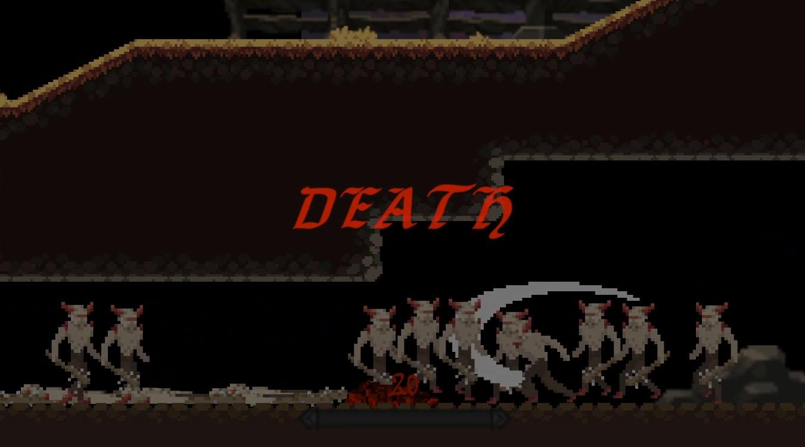

# 8 Game Rules

* The player is allowed to movement left, right, up, and down
* The player is allowed to crouch to traveling in crevcasses
  + Enemies cannot crouch
* The player is allowed to hang on walls and climb up them
* The player is allowed to jump
  + But can only do when hanging or on GROUND
* Enemies are able to hang on walls and climb up them
* The player is allowed to attack (swing sword)
  + The player cannot attack in air
  + The player cannot attack while being stunned
  + Attacking enemies temporarily stuns them
* Enemies are allowed to attack (swing club)
  + Enemies CAN attack in air
  + Enemies cannot attack while being stunned
  + Attacking the player temporarily stuns them
* While attacking, both player and enemy have their speed reduced
* The player is allowed to do evasive rolls
  + While rolling, the player can pass through enemies
  + While rolling, the player’s speed is increased
  + In order to roll, the player must have momentum forward
* The player cannot leave the map
  + Moving outside the map will push them back towards the play field
  + If stuck outside the map the player will spawn in the playing field
* The player has a short pause in-between attacks
  + However attacking continuously will shorten these pauses
* Whenever the current enemies present is less than the “enemyAllowed” value, new enemies will be spawned
  + Enemies will be spawned in only nodes valid to hold their collider

# 9 Game Structure

* The game is structured into rounds of endless enemy spawning until the kill quota is reached
* Ending the game…

1. The player reaches the kill quota and all enemies are despawned, ensuring the player’s survival
2. The player’s health is depleted to or past 0. The enemies are still prevalent and all the player’s controls are locked
3. The player returns to the main menu or exits the game through the Pause menu

* These rounds of spawning are categorized by difficulty
  + Easy, Medium, Hard

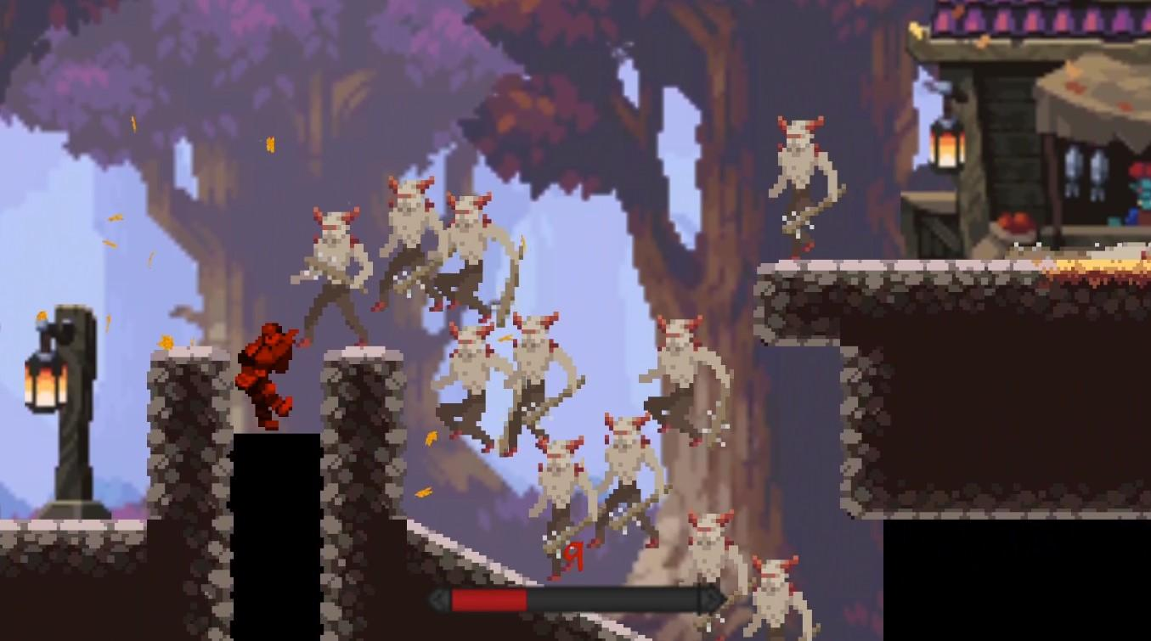

# 10 Game Play

## 10.1 Game Controls

* Movement
  + WASD - Left, Up, Right, Down
  + S - Crouch
    - Can be paired with A or D to crouch walk
  + W - Jump
    - Can be paired with A or D to move in air
  + W near a Wall - Wall climb
* Combat
  + Left Click OR Spacebar - Strike #1
  + Left Click OR Spacebar *immediately right after* - Strike #2
    - Just as strong, but faster
* Evasion
  + Shift - Roll
    - Increases speed and allows temporarily passage through enemy colliders

## 10.2 Game Camera

* The game camera features a Cinemachine script, which actively tracks onto the player’s position
  + Uses slight dampening to ease sudden movements
* Camera adheres to the map’s boundaries, meaning player view will never intrude outside the game’s boundaries

### 10.2.1 HUD

* Game features a health bar to indicate player health
* Game features “Death” and “Victory” screens to indicate once the current run has ended
  + Allows for replay or returning to menu
* Game features a Pause menu
  + Allows run modification through turning on/off music
  + Features outlining of user controls

### 10.2.2 Maps

* The game does not feature a visual display of the map
  + In not providing a map, the player is forced to explore to understand all possible routes for evading enemies
* However, the camera does move slightly ahead of the player’s direction to allow for partial “Look Ahead” functionality

# 11 Players

## 11.1 Characters

* “Guts” (Player)
  + Can have name and outfit color customized
  + Deals 35 damage and has 200 health
  + Can roll and crouch
* Demon Imps
  + Deal 35 damage and has 200 health
  + Gather in hordes to overwhelm player
  + Cannot crouch nor roll
  + Can swing club in air

## 11.2 Metrics

* Health
  + Hit points representing how many hits entity can take before death
* Attack Speed
  + How fast for the actual swing of the attack to take place
  + Also dependent on attack rate…
    - Time in between an entity’s attacks
* Speed
  + How fast the entity can move laterally
* Jump force
  + How high the entity can jump upwards
  + Also dependent on jump rate…
    - Time in between an entity’s jumps

## 11.3 States

* Unaffected
  + State where entity can move and attack freely
* Stunned
  + State after an attack where entity has no control over movement and cannot attack
  + Entity travels in opposite direction of attack
* In Air
  + (Player) Can control movement but cannot attack
* Alive
  + State where entity’s health is above 0
  + Actions corresponding to unaffected
* Dead
  + State where entity’s health has reached or dropped below 0
  + Entity’s position is frozen and cannot attack

## 11.4 Weapons

* Knight Sword
  + Does 35 damage
  + Faster hit rate than club
  + Can be swung progressively faster with *Strike #1* and *Strike #2*
* Demon Club
  + Does 35 damage
  + Has “charging” period where Demon Imp readys swing
    - Provides window for player to strike and cancel attack entirely

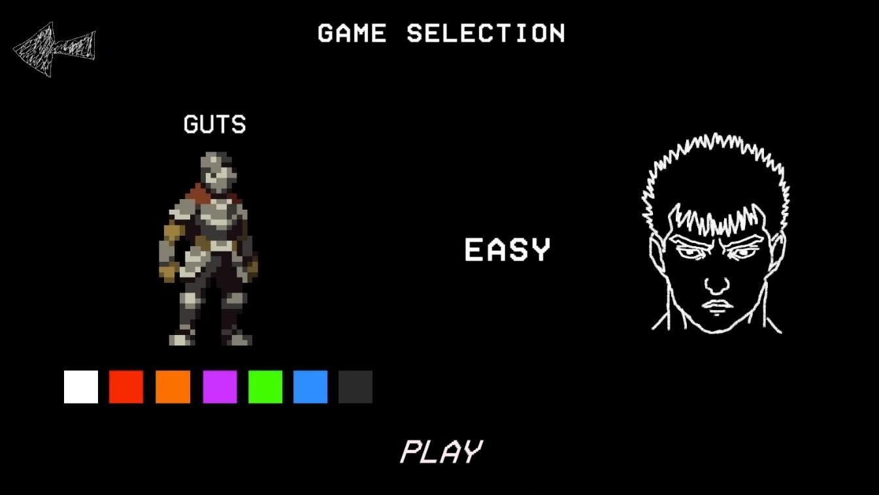

# 12 Player Line-up

* “IT TAKES GUTS” features only 1 player-controlled entity
  + Knight, i.e Guts
    - Wields Knight Sword
    - Can wall climb
    - Can roll and crouch

# 13 NPC

# 13.1 Enemies

* Demon Imps
  + There is only 1 type of enemy

### 13.1.1 Enemy States

* Unaffected
  + State where entity can move and attack freely
* Stunned
  + State after an attack where entity has no control over movement and cannot attack
  + Entity travels in opposite direction of attack
* In Air
  + (Enemyr) Can both control movement and attacking
* Alive
  + State where entity’s health is above 0
  + Actions corresponding to unaffected
* Dead
  + State where entity’s health has reached or dropped below 0
  + Entity’s position is frozen and cannot attack

### 13.1.2 Enemy Spawn Points

* Through the A*Star Pathfinding Project, the given map is sectioned off into nodes that objects can travel through
  + Dependent on whether or not a collider is present in the node
  + These nodes indicate all the spaces an Enemy Imp would fit in
* Enemy Spawning is entirely randomly throughout the map, however it only considers and processes the map’s valid nodes to avoid spawning into walls, floors, and other colliders
* By taking all valid nodes, this also includes space in the open air
  + Enemy spawns are momentarily marked by a portal sprite, which disappears shortly after

## 13.2 Allies / Companions

* There are no allies nor companions in this game

### 13.2.1 Ally States

* n/a

### 13.2.2 Ally Spawn Points

* n/a

# 14 Art

## 14.1 Setting

* This game is set in a forest during Fall
  + Trees of colors yellow, orange, and brown are prevalent throughout
  + Animated sprites of leaves falling as well
* For games caverns’, dirt walls and stray rocks are scattered throughout these areas
* Player-only passageways are subliminally hidden or shown prevalently
  + One crouch passageway is blocked a fence in the foreground
  + One tunnel shoot extends significantly above ground level
* A shopkeep is present on the floating platform to indicate nearby civilization
  + Entirely in the foreground

## 14.2 Level Design

* The game is structured with a map that features 3 main levels
  + Upper on top, Middle between, Lower at bottom
  + Upper
    - One long platform in top middle
  + Middle
    - Base floor with several gaps into Lower level and walls to scale up towards Upper
      * 3 gaps on Left side, Middle, and Right side
  + Lower
    - Beneath ground level that features 3 openings towards Middle level
      * 3 gaps on Left side, Middle, and Right side
* Certain gaps traveling between map layers are untraversable by enemy
  + Enemy has ability to scale walls, but certain gaps are too big for them
    - But just the right size for player
    - This initiates AI pathfinding in moving in a separate direction to cutoff player

## 14.3 Audio

* Menu Audio
  + Audio features music to play more into Dark Fantasy theme
    - Hymns, Opera, and Drums
  + “Aria” from the BERSERK Manga Series
  + End game music…
    - Victory -> Cheerful ring of celebration
    - Death -> Dreary tune of disappointment
  + Whenever a button is pressed, a “select” effect is played
* Player Audio
  + Whenever the player dies, he groans
  + Whenever the player jumps, he grunts
  + Whenever the player swings his sword, his sword’s wisp is heard
    - Differs between Strike #1 and Strike #2
  + Whenever the player hits an enemy, the contact is heard
    - Differs between Strike #1 and Strike #2
  + Whenever the player moves, his footsteps are heard
  + When the player moves while crouched, softer, less audible footsteps are heard
* Enemy Audio
  + Whenever the enemy dies, he lets out a yell
  + Whenever the enemy is hit, he lets out a grunt
    - There is a 50% chance the enemy will let out a voice indicating the enemy’s current health instead of the grunt
      * 75%-100% of health, the enemy laughs
      * 50%-75% of health, the enemy murmurs
      * 25% -50% of health, the enemy roars
  + Whenever the enemy swings, his club’s wisp is heard
  + Whenever the enemy lands a hit, his club’s contact is heard
* Environment Audio
  + At the start of every round, a “threat” from the Demons is audible
    - 3 different intro threats available, determines which one to play based off C# Random
  + In the woodlands, birds and running water can be heard
  + When an enemy spawns, their respective portal can be heard
* Game Music
  + If the players checks a toggle in the Pause Menu, battle music will play
    - “My Brother” from BERSERK Manga Series

# 15 Procedurally Generated Content

## 15.1 Environment

* When an enemy is killed, they perform a death animation and lie down on the ground
  + Location of enemies’ corpses throughout rounds differs based on difficulty and where each player-enemy encounter occurs

## 15.2 Levels

* The environment is not procedurally generated

## 15.3 Artificial Intelligence NPC

* Enemies’ procedural generation involves their spawn point and their path
  + Spawn
    - Differs based on map’s viable nodes and the static Random’s output values
  + Paths
    - According to player’s location, enemies will follow the shortest path to the player’s position
      * Adheres to the available A* nodes
        + A player and enemy might be next to each other, but if the space in between is deemed ineligible for travel, the enemy will find a longer route around

Out of all “possible” routes, this would still be the shortest one

## 15.4 Visual Arts

* The visual arts are not procedurally generated

## 15.5 Audio

* Audio heard throughout the round varies based on which enemies are fought
  + Enemies w/ lower health have chance to do war cry
  + Enemies w/ higher health have chance to laugh
    - Inevitable total audio playing differs per round
* Demon threat heard at round’s start differs based on Random
  + Independently different each round

## 15.6 Minimum Viable Product (MPV)

* The minimum viable product to be delivered on will be
  + A 2D Hack ‘N Slash Platformer
  + Animations for player and enemy actions
  + A map with varying pathways throughout
  + Accurate player tracking
  + Applicable enemy spawning
  + Proper UI and endgame scenarios implemented
  + Health and Combat system
  + Some variety of dynamic movement present
    - Crouching, Rolling

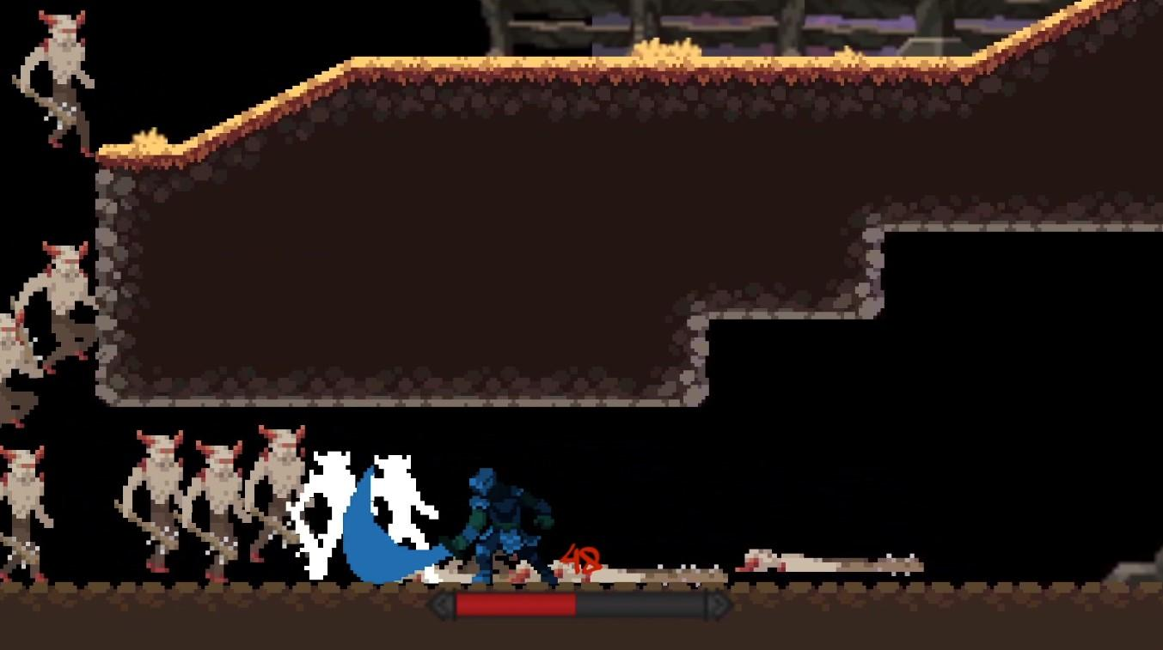

# 16 Wish List

* Implement Allies to help fight Demons
* Implement a shop to improve upon weapons
* Implement a Bow & Arrow to allow for ranged attacks
* Implement different types of enemies
  + Faster, smaller enemies
  + Slower, bigger enemies
  + Flying enemies
  + Big boss
* Implement variations of melee strikes
  + Later introduce a combo system
    - Combo multiplier
* Add more maps
* Add cutscenes to tell a narrative story

## 17 Satisfying Requirements

*Individual 2D Game*

* Utilizes components from 2D Api (BoxCollider2D, Rigidbody2D)
* Includes a GDD
* Includes title & credits screen with transitions
* Implements player selection screen to customize name, in-game color, and difficulty
  + Name is persisted through Pause menu
  + Color is persisted through player appearance
  + Difficulty is persisted through enemy count
* All game assets are free or of my own original work
* Game includes full working and adjustable audio throughout
* Game includes working animations for movement, attacking, and death
* Bibliography.txt file included
* Includes a working executable
* Coded in C# with Unity3D 2020.3+
* gitignore file included

*2D Game Design Document*

* Documents all available sections
  + Including objective, genre, other games’ inspiration, and a bibliography
* Every resource is cited in APA format
* Screenshots included of gameplay

## 18 Bibliography

References

aamatniekss. (n.d.). *Fantasy Knight - free Pixelart animated character*. itch.io. Retrieved April 27, 2022, from <https://aamatniekss.itch.io/fantasy-knight-free-pixelart-animated-character>

adwitr. (n.d.). *Pixel Health Bar Asset Pack 2*. itch.io. Retrieved April 27, 2022, from <https://adwitr.itch.io/pixel-health-bar-asset-pack-2>

Antarsoft. (2020, August 10). *Simple Crouching*. Youtube. Retrieved April 27, 2022, from <https://www.youtube.com/watch?v=ET59LPjfFfo&t=565s&ab_channel=Antarsoft>

Antarsoft. (2020, September 9). *Unity 2D Platformer*. YouTube. Retrieved April 27, 2022, from <https://www.youtube.com/watch?v=iX0BEiJTjrE&t=266s&ab_channel=Antarsoft>

Antoine, G. (2021, October 4). *Nature sounds pack - free: Audio Sound FX*. Unity Asset Store. Retrieved April 27, 2022, from <https://assetstore.unity.com/packages/audio/sound-fx/nature-sounds-pack-free-202076>

Artmasterrich. (2016, May 8). *Male_jump_01* . Freesound. Retrieved April 27, 2022, from <https://freesound.org/people/Artmasterrich/sounds/345437/>

Aurecon_Unity. (2014, November 25). *How to disable (hide) UI elements without disabling them*. Unity Forum. Retrieved April 27, 2022, from <https://forum.unity.com/threads/how-to-disable-hide-ui-elements-without-disabling-them.282100/>

Bardent. (2020, March 23). *How to deal with slopes! in unity 2D using built ... - youtube*. YouTube. Retrieved April 28, 2022, from <https://www.youtube.com/watch?v=QPiZSTEuZnw&ab_channel=Bardent>

Belt, W. van den. (2011, February 28). *A Dripping Marker*. DaFont. Retrieved April 27, 2022, from <https://www.dafont.com/a-dripping-marker.font>

Berserk. (2009, January 25). 4 Gatsu. *YouTube*. Retrieved April 27, 2022, from <https://www.youtube.com/results?search_query=Berserk+-+4+Gatsu>.

Berserk. (2015, May 5). Aria. *YouTube*. Retrieved April 27, 2022, from <https://www.youtube.com/watch?v=CGcv09G5MYc&t=66s&ab_channel=Albireo>.

Berserk. (2017, May 28). My Brother the Dragonslayer. *Youtube*. Retrieved April 27, 2022, from <https://www.youtube.com/watch?v=lBdnti4_UUg&ab_channel=UnseenPhantom>.

Blackthornprod. (2018, July 18). *How to Make UI in Unity*. Youtube. Retrieved April 28, 2022, from <https://www.youtube.com/watch?v=_RIsfVOqTaE&ab_channel=Blackthornprod>

Brackeys. (2017, April 12). *How to build / export your game in unity*. YouTube. Retrieved April 28, 2022, from <https://www.youtube.com/watch?v=7nxKAtxGSn8>

Brackeys. (2017, December 20). *Pause menu in Unity - YouTube*. YouTube. Retrieved April 28, 2022, from <https://www.youtube.com/watch?v=JivuXdrIHK0>

Brackeys. (2017, March 19). *GAME OVER - How to make a Video Game in Unity*. YouTube. Retrieved April 28, 2022, from <https://www.youtube.com/watch?v=VbZ9_C4-Qbo>

Brackeys. (2017, May 31). *Introduction to audio in Unity - YouTube*. YouTube. Retrieved April 28, 2022, from <https://www.youtube.com/watch?v=6OT43pvUyfY>

Brackeys. (2017, November 19). *Start menu in Unity - YouTube*. YouTube. Retrieved April 28, 2022, from <https://www.youtube.com/watch?v=zc8ac_qUXQY>

Brackeys. (2017, October 8). *Intro to Unity Timeline - Youtube*. YouTube. Retrieved April 28, 2022, from <https://www.youtube.com/watch?v=G_uBFM3YUF4>

Brackeys. (2018, August 5). *2D animation in Unity (tutorial) - youtube*. Youtube. Retrieved April 28, 2022, from <https://www.youtube.com/watch?v=hkaysu1Z-N8>

Brackeys. (2018, January 31). *TILEMAPS in Unity - YouTube*. Youtube. Retrieved April 28, 2022, from <https://www.youtube.com/watch?v=ryISV_nH8qw>

Brackeys. (2018, September 9). *2D Camera in Unity*. YouTube. Retrieved April 27, 2022, from <https://www.youtube.com/watch?v=2jTY11Am0Ig&list=PLPV2KyIb3jR6TFcFuzI2bB7TMNIIBpKMQ&index=6&ab_channel=Brackeys>

Brackeys. (2019, December 16). *Melee combat in Unity*. Youtube. Retrieved April 27, 2022, from <https://www.youtube.com/watch?v=sPiVz1k-fEs&ab_channel=Brackeys>

Brackeys. (2019, June 16). *2D lights in unity!* YouTube. Retrieved April 28, 2022, from <https://www.youtube.com/watch?v=nkgGyO9VG54>

Brackeys. (2019, June 2). *2D pathfinding - enemy AI in unity - youtube*. YouTube. Retrieved April 28, 2022, from <https://www.youtube.com/watch?v=jvtFUfJ6CP8>

Brackeys. (2020, February 9). *How to make a health bar in unity!* YouTube. Retrieved April 28, 2022, from <https://www.youtube.com/watch?v=BLfNP4Sc_iA>

Brackeys. (2020, January 12). *How to make awesome scene transitions in unity*. YouTube. Retrieved April 28, 2022, from <https://www.youtube.com/watch?v=CE9VOZivb3I>

Brullov. (n.d.). *Oak Woods - Environment Asset*. itch.io. Retrieved April 27, 2022, from <https://brullov.itch.io/oak-woods>

Coco Code. (2020, December 10). *Create great GAME OVER screen in Unity UI*. YouTube. Retrieved April 28, 2022, from <https://www.youtube.com/watch?v=K4uOjb5p3Io&ab_channel=CocoCode>

Code Monkey. (2019, April 26). *How to use a Custom Font with Text Mesh Pro*. YouTube. Retrieved April 28, 2022, from <https://www.youtube.com/watch?v=nBcP7FaDPE0&ab_channel=CodeMonkey>

codemanu. (n.d.). *Free Pixel Effects Pack*. itch.io. Retrieved April 27, 2022, from <https://codemanu.itch.io/pixelart-effect-pack>

CodeMonkey. (2018, August 13). *How to make a health bar*. YouTube. Retrieved April 28, 2022, from <https://www.youtube.com/watch?v=Gtw7VyuMdDc>

Coding in Flow. (2021, June 17). *Sound Effects & Background Music*. YouTube. Retrieved April 27, 2022, from <https://www.youtube.com/?gl=DE>

CraftedGaming. (2019, June 29). *Unity placing a UI on top of Cinemachine*. Game Development Stack Exchange. Retrieved April 27, 2022, from <https://gamedev.stackexchange.com/questions/173296/unity-placing-a-ui-on-top-of-cinemachine>

Dapper Dino. (2018, March 6). *Unity Video Player*. YouTube. Retrieved April 27, 2022, from <https://www.youtube.com/watch?v=OdVGyV3rTGs&ab_channel=DapperDino>

Etredal. (2020, September 7). *Advanced AI in Unity*. YouTube. Retrieved April 27, 2022, from <https://www.youtube.com/watch?v=sWqRfygpl4I&ab_channel=Etredal>

Gneube. (2015, July 13). *Leather bag drop*. Freesound. Retrieved April 27, 2022, from <https://freesound.org/people/gneube/sounds/315838/>

gpag1. (2017, May 6). *Monster screams*. Freesound. Retrieved April 27, 2022, from <https://freesound.org/people/gpag1/sounds/391552/>

Granberg, A. (2021, November 6). *A* Pathfinding Project V. 4.2.17*. Game Development with Unity. Retrieved April 27, 2022, from <https://arongranberg.com/astar/>

*Hit Sound Effects*. Mixkit. (n.d.). Retrieved April 27, 2022, from <https://mixkit.co/free-sound-effects/hit/>

icebear007. (n.d.). *white images with material "none" rendered green*. Unity Forum. Retrieved April 27, 2022, from <https://forum.unity.com/threads/solved-white-images-with-material-none-rendered-green.454488/>

James, C. (2020, August 9). *A beginners's guide for post-processing for Unity 2D*. Medium. Retrieved April 27, 2022, from <https://cjames1.medium.com/a-beginnerss-guide-for-post-processing-for-unity-2d-843874f333a1>

Kaiserzharkhan. (2012, December 5). *Seagram TFB*. Dafont. Retrieved April 27, 2022, from <https://www.dafont.com/seagram-tfb.font>

Leal, R. (2014, April 14). *VCR OSD Mono Font*. DaFont. Retrieved April 27, 2022, from <https://www.dafont.com/vcr-osd-mono.font>

Little Robot Sound Factory. (2015, July 16). *Fantasy SFX: Audio sound FX*. Unity Asset Store. Retrieved April 27, 2022, from <https://assetstore.unity.com/packages/audio/sound-fx/fantasy-sfx-32833>

Lost Relic Games. (2020, April 17). *Fixing Rigidbody Jitter*. YouTube. Retrieved April 27, 2022, from <https://www.youtube.com/watch?v=XQ_w9iZl0UM&ab_channel=LostRelicGames>

Matthew0123. (2013, January 12). *How delete or remove a component of an gameobject?* Unity Answers. Retrieved April 27, 2022, from <https://answers.unity.com/questions/378930/how-delete-or-remove-a-component-of-an-gameobject.html>

meat5000. (2013, August 30). *Why can't my enemies walk up an incline?* Unity Answers. Retrieved April 27, 2022, from <https://answers.unity.com/questions/526651/why-cant-my-enemies-walk-up-an-incline.html>

Merrick079. (2021, April 15). *Sword sound 2*. Freesound. Retrieved April 27, 2022, from <https://freesound.org/people/Merrick079/sounds/568169/>

Mixkit. (n.d.). *Download Free Game Sound effects*. Mixkit. Retrieved April 27, 2022, from <https://mixkit.co/free-sound-effects/game/>

Mixkit. (n.d.). *Monster Sound Effects*. Mixkit. Retrieved April 27, 2022, from <https://mixkit.co/free-sound-effects/monster/>

Modding by Kaupenjoe. (2021, August 14). *Making an Enemy Spawner*. YouTube. Retrieved April 27, 2022, from <https://www.youtube.com/watch?v=SELTWo1XZ0c&ab_channel=ModdingbyKaupenjoe>

NeatoShop. (n.d.). *Pixel Guts Logo*. NeatoShop. Retrieved April 27, 2022, from <https://www.neatoshop.com/product/Pixel-Guts>

nick121087. (n.d.). *Demonic woman Scream*. Freesound. Retrieved April 27, 2022, from <https://freesound.org/people/nick121087/sounds/333832/>

Norderhaug, Anthony. (2022). *Demon sketches*, Various pictures of demons for game pause menu.

Oldestmillennial. (2020, August 29). *Dark Teleport*. Freesound. Retrieved April 27, 2022, from <https://freesound.org/people/oldestmillennial/sounds/533025/>

Root Games. (2021, July 18). *Pixel Perfect Camera with Cinemachine*. YouTube. Retrieved April 27, 2022, from <https://www.youtube.com/watch?v=xGz7uMjeRRQ&ab_channel=RootGames>

Samyam. (2020, December 17). *Cinemachine Confiner*. YouTube. Retrieved April 28, 2022, from <https://www.youtube.com/watch?v=izumXk-xoEM>

sanctumpixel. (n.d.). *Imp & Axe Demon Pixel art character by sanctumpixel*. itch.io. Retrieved April 27, 2022, from <https://sanctumpixel.itch.io/imp-axe-demon-pixel-art-character>

strich. (2012, August 14). *How do you allow animations to interrupt each other?* Unity Forum. Retrieved April 27, 2022, from <https://forum.unity.com/threads/how-do-you-allow-animations-to-interrupt-each-other.313216/>

sully. (2020, November 30). *Rigidbody 2d Jittery*. Unity Answers. Retrieved April 27, 2022, from <https://answers.unity.com/questions/1793291/rigidbody-2d-jittery.html>

Sunny Valley Studio. (2022, February 1). *How to Save Data between Scenes in Unity*. YouTube. Retrieved April 27, 2022, from <https://www.youtube.com/watch?v=MBM_4zrQHao&ab_channel=SunnyValleyStudio>

Tarodev. (2021, March 20). *2D Camera in Unity + Confining to Bounds*. YouTube. Retrieved April 27, 2022, from <https://www.youtube.com/watch?v=xxshfe3yzqA&ab_channel=Tarodev>

Techstacker. (2020, July 29). *"help, things disappear when I hit the play (render) button in unity"*. TechStacker RSS. Retrieved April 27, 2022, from [https://techstacker.com/things-disappear-on-play-render-in-unity/#](https://techstacker.com/things-disappear-on-play-render-in-unity/)

Terresquall. (2022, February 22). *"How to fix misaligned Tiles in Unity's 2D Tile Palette"*. YouTube. Retrieved April 27, 2022, from <https://www.youtube.com/watch?v=3KpdT7189Kw&ab_channel=Terresquall>

Thuddleston. (2017, June 22). *Guts black and white*. DeviantArt. Retrieved April 27, 2022, from <https://www.deviantart.com/thuddleston/art/Guts-Black-and-White-684995593>

tonsil5. (2018, January 28). *Grunt2 - death pain*. Freesound. Retrieved April 27, 2022, from <https://freesound.org/people/tonsil5/sounds/416838/>

Twimg. (n.d.). *Image of Guts Sleeping*. Twimg. Retrieved April 27, 2022, from <https://pbs.twimg.com/media/E11cBm3XMAcADYE?format=jpg&name=small>

Unity Official Youtube. (2020, September 21). *Creating a third person camera using Cinemachine in unity ...* YouTube. Retrieved April 28, 2022, from <https://www.youtube.com/watch?v=537B1kJp9YQ>

user-11877. (2011, April 22). *Enemy prefab doesn't follow player*. Unity Answers. Retrieved April 27, 2022, from <https://answers.unity.com/questions/59904/enemy-prefab-doesnt-follow-player.html>

Vdarned. (2013, October 29). *Why is my character controller not colliding with Collisiders?* Unity Answers. Retrieved April 27, 2022, from <https://answers.unity.com/questions/565859/why-is-my-character-controller-not-colliding-with.html>

VGcomposer. (2019, August 30). *Action RPG music free: Audio music*. Unity Asset Store. Retrieved April 27, 2022, from <https://assetstore.unity.com/packages/audio/music/action-rpg-music-free-85434>